# Steps to use this component

## Export and Upload

1. Download the content of the folder **cc-monaco-editor** as a ZIP
2. Go to your Visual Builder, Open the components pallet. Scroll down to bottom to ‘**Custom**’
3. Add a new component, Upload the ZIP file from Step 1.

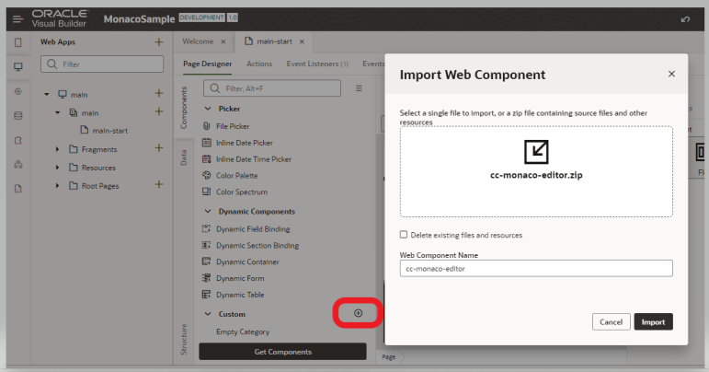

## Usage

1. Since this component requires an external library plugin we first need to load that library.
2. Go to the root of the app, open the JSON and add an requirejs block (if not already present) or just add a new entry to paths (if already present) as shown below.

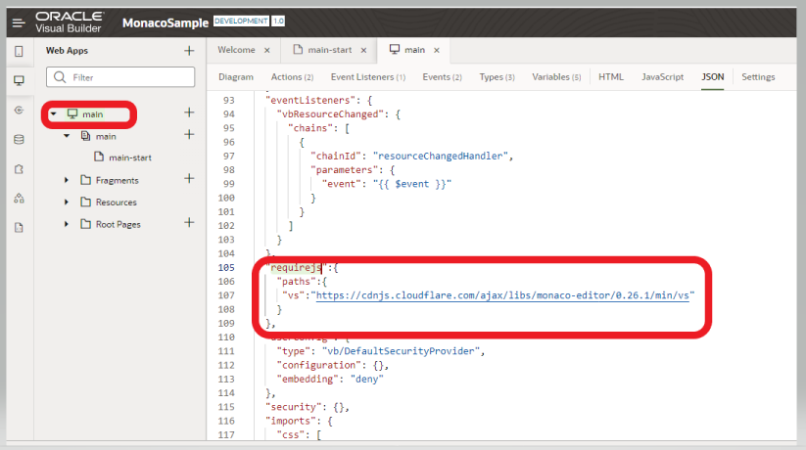

"requirejs":{

    "paths":{

     "vs":"https://cdnjs.cloudflare.com/ajax/libs/monaco-editor/0.26.1/min/vs"

    }

  },

1. Now in the page where you want to use just drag and drop the new component.

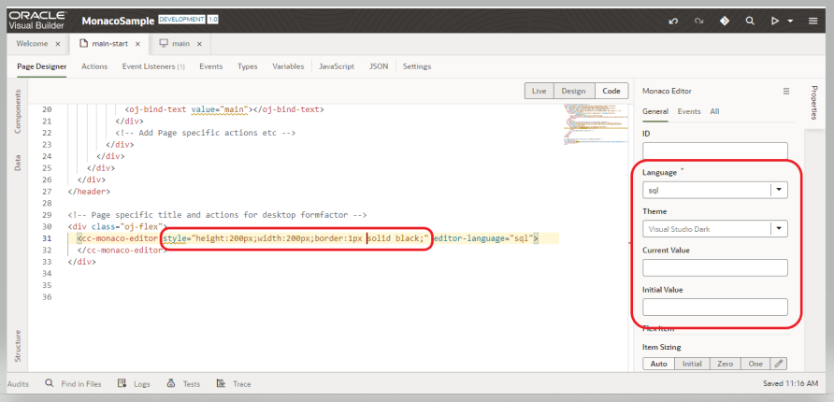

## Properties

1. Language: The language of the code which will help in proper syntax highlighting
2. Theme: The themes supported by VS Code
3. Current Value (**ReadOnly**): Bind this to a variable which will contain the data entered into the editor.
4. Initial Value: The default text that needs to be present in the editor with which the rendering will start. Any change of this variable after the component is rendered will not impact the editor.

Note: Style attribute is used to control the width and height of the editor.

<div class="oj-flex">

  <cc-monaco-editor style="height:200px;width:600px;border:1px solid black;" editor-language="sql"

    editor-value="{{ $variables.editorValue }}"

    editor-initial-value="[[ $variables.editorInitialValue ]]">

  </cc-monaco-editor>

</div>

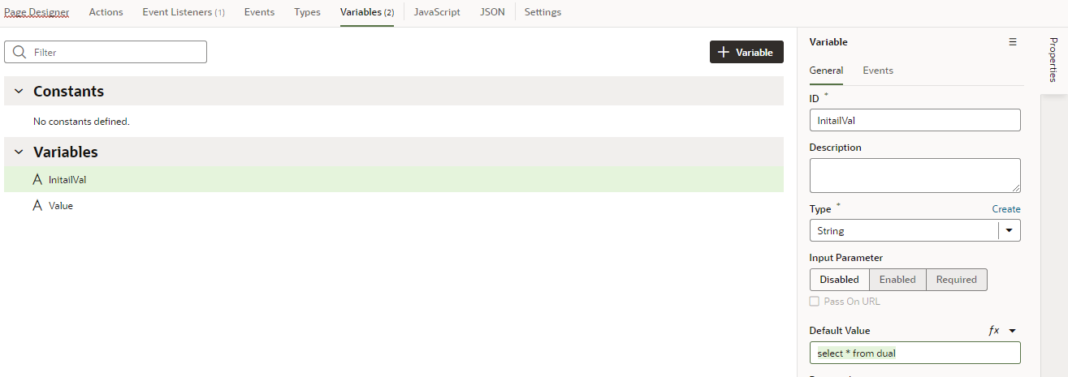

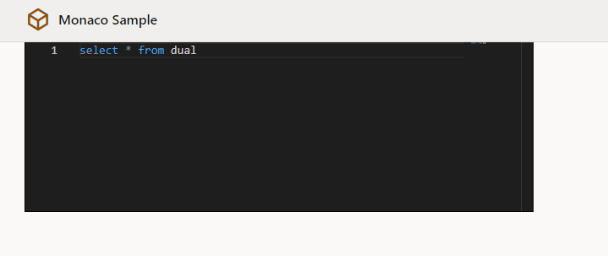

Export of the application : 